
SAMAKI SALAMA PROJECT QUALITATIVE RESEARCH FOCUS DISCUSSION GROUP 1
2022

Samaki Salama Project Qualitative Research- Focus Group Discussion 1

- Introduction

The Samaki Salama project team conducted a study in the community of Mkwajuni near Lake Jipe in Taita Taveta County on October 8, 2022. It was attended by 12 mothers/caregivers. The subject was access to fish and beliefs about eating fish. This aspect was better understood by listening to the opinions, perceptions, and ideas by asking the caregivers/mothers questions. The team assured the mothers/caregivers that there were no wrong or right answers in this case, but the opinions were the most important for our reporting.
The mothers/caregivers were welcome to share ideas and ask any questions in case they have not understood. The Samaki Salama team took asked for their consent after the study was explained and they all agreed and requested to take pictures and record the people’s statements for the accuracy of reporting. The community leader signed the consent form on behalf of the mothers.
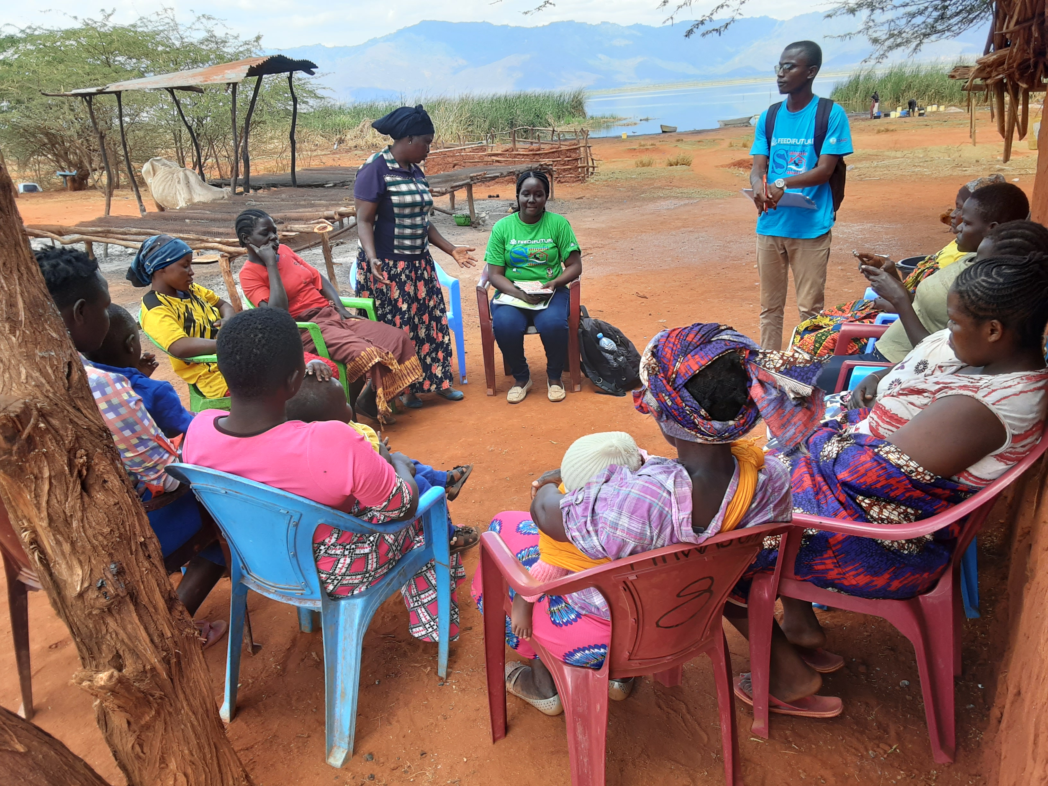
Focus discussion group with mothers/caregivers in Mkwajuni Village in Lake Jipe

- Demographics
Participant 1- Has a child who is 4 years 6 months and her occupation is scaling fish. She has gone to school up to class 8.
Participant 2- Has a child who is 3 years 6 months and her occupation is scaling fish. She has gone to school up to the level of the fourth form.
Participant 3- Has a child who is 3 years 6 months and her occupation is scaling fish. She had gone to school up to the level of class 7 in Tanzania (Country)
Participant 4- Has a child who is 1 year and 2 months and her occupation is scaling fish for the traders. She has gone to school up to the level of class 8.
Participant 5- Has a child who is 2 years old and her occupation is scaling fish. She mentioned having left school at class 6.
Participant 6- Has a child who is 2 years 5 days and her occupation is scaling fish. She has gone to school up to the level of form 4.
Participant 7- Has a child who is 3 years and her occupation is scaling fish for the traders. She has gone to school up to the level of class 7 in Tanzania
Participant 8- Has a child who is 4 years and her occupation is scaling fish for the traders. She has gone to school up to form 2.
Participant 9- Has a child who is 1 year 6 months and her occupation is scaling fish for the traders. She has gone to school up to the level of class 3 in the primary.
Participant 10-Has a child who is 5 years and her occupation is scaling fish. She has gone to school to the level of form 3.
Participant 11-Has a child who is 3 years 6 months and takes care of her grandchild who is 3 months old. Has gone to school up to the level of form 4.
Participant 12- Has a child who is 2 years and her occupation is scaling fish. She has gone to school up to the level of class 7 in the Tanzanian (Country) system.

- Opinions about fish in the community
The mothers/caregivers reported that they do not have specific customs around fish since different tribes live in the areas around the lake. They mentioned that if it was indeed a custom is that they like feeding their children fish and it is what they eat with everything else. The mothers added that a certain community called the Luo are the ones that like eating fish. Another community called the Maasai who are pastoralists do not like eating fish, but they have noticed the younger generation begin to eat fish.

- Source of fish in the community
The mothers/caregivers reported that their only source of fish is the Lake. It was mentioned that one buys fresh raw fish at the beach according to the much one can afford. The fish are bought from the fishermen which are usually cheaper as compared to buying from the traders. Once the traders have bought the fish the price of the fish hikes. Other respondents added that they borrow fish from traders or fishermen when they lack the finances to buy fish. The fish that is borrowed is usually very small in size. One is usually given 10 pieces about the size of two fingers. The mothers/caregivers added that those involved in the business of scaling fish sometimes are given some fish by the trader as a form of payment. In terms of quantity, fish about palm size is usually sold 4 pieces at sh. 100 and sometimes it depends on the grade of the fish. The bigger the fish the more the price. The small fish about half-palm size are placed 3 pieces bunches and sold at sh.10. The types of fish caught in Lake Jipe include Tilapia and Mudfish.
- Challenges people in the community have to try to get fish to eat
- Participant 1: Sometimes fishermen are rude when one goes to borrow fish from them, and one ends up not getting fish.
- Participant 2: The traders sometimes buy all the fish from the fishermen and refuse to sell to the locals. The fish also hike the fish prices making it expensive for the locals to buy.
- Participant 3: Lack of finances to buy fish especially when the husband has not gone fishing that day.
- Opinions about the positive qualities of fish
- Nourishment
Participant 1: Fish is good according to science it has proteins
Participant 2: Fish makes one bright, especially a child. One becomes clever like the fish itself “Anapea watu akili” she said. Fish does not have any negative qualities.
- Digestibility
Participant 1: Fish is easily digestible which is why it can be given to an infant who is 6 months old.
- Taste
Participant 1: Fish is very delicious.
Participant 2: Fish is tasty, and I depend on how one cooks it. Adding spices and other vegetables makes it more delicious.
Participant 3: One should not wash fish with lots of water since that takes the good flavor away. Fish should be washed only twice with clean water after scaling.
- Ease of preparation
Participant 1: Fish is very easy to prepare. One can boil with little water and add salt to taste and still it will be delicious and easy for the child to eat.
Participant 2: Fish can also be roasted “Kubanika” – local language. This is also a technique of preservation.
Participant 3: It only takes 15 minutes for the fish to be ready.
- Availability
Participant 1: Fish is available at the lake, but the challenge sometimes is lacking the finances to buy it.
Participant 2: Drought has affected the availability of fish. The number and size that is caught at the lake have reduced drastically.
- Cost
Participant 1: Fish is very affordable. At sh. 50 one can feed the family to satisfaction but for food like maize flour is sh. 100 per kg and beans are sh. 170 per kg.
Participant 2: Fish is less expensive compared to vegetables. People prefer eating fish to getting vegetables which are never enough for the family.
Negative qualities of fish
Participant 1: Mudfish causes an allergic reaction in particular people, especially children. The children a skin irritation and rashes that subsides after some time. Apart from that, there are no negative qualities of fish.
- Knowledge about fish as a food for the family and young children
- Participant 1: Fish provides energy
- Participant 2: Children grow healthy when they are fed fish
- Participant 3: Fish can be eaten even without Ugali. It can be boiled and fed to children and that will still be a meal.
- Participant 4: Fish helps prevent diseases in children and even adults.

- Comparison of fish to Animal protein
The mothers/caregivers mentioned that chicken, beef, milk, and eggs are other available proteins. The Mothers/caregivers gave the following responses according to the
- Nourishment
Participant 1: Fish has more nutrients and is beneficial to health because it is white meat, unlike beef which is a red meat that causes disease.
Participant 2: Fish has more nutrients compared to chicken since some are allergic.
Participant 3: People with chronic conditions such as diabetes and hypertension are advised against eating beef, chicken, and eggs due to the fat, but they are encouraged to eat boiled fish.

- Digestibility
Participant 1: Milk is easily digestible compared to fish and other meats

- Taste
Participant 1: Fish has the best taste compared to beef and eggs.
Participant 2: Fish is delicious even if it is boiled and salt added to taste

- Ease of preparation.
Participant 1: It is easy to prepare fish and it takes a quarter an hour to be ready, unlike chicken and beef which must be boiled for some time before they are ready.
Participant 2: Fish can be boiled, Roasted, or deep fried. These are easy methods of cooking therefore it is easy to prepare.

- Availability
Participant 1: Fish is still available even though the amounts and size have reduced in the lake.
Participant 2: Beef is only available once a year and mostly during occasions or when they die of hunger.
Participant 3: Eggs are available at the shops but are very expensive. Chicken reared at home rarely lay eggs due to the lack of food caused by the drought.
Participant 3: Milk is only available in the rainy season. This drought has caused it to be very expensive and residents are unable to buy from the shops.
- Cost
Participant 1: Beef is very expensive and can only be eaten once a year, but fish is readily available in the lake and their husbands who are fishermen bring the catch home.
Participant 2: The coat of fish has gone up since the draught came in, but one would rather buy fish than buy beef, eggs, or milk.

- Comparison of fish to plant protein
- Nourishment
Participant 1: Fish has more nutrients than beans. When a child is sick, the mother is advised by the doctor or the community health volunteer to give more fish.
Participant 2: When the oil from fish is boiled well, it can be given to a child who has a respiratory condition and feels better. The dosage is usually 2 teaspoons every day.

- Digestibility
Participant 1: Fish does not cause any stomach upset in children and even in adults.
Participant 2: When one has a stomach condition, one is advised not to eat beans but there is no day one has been advised not to eat fish
- Taste
Participant 1: Fish is very delicious even if it is only boiled with water and salt.
- Ease of preparation.
Participant 1: Fish is easy to prepare through several methods. One can prepare by boiling, roasting, deep frying, and stewing and it takes only a few minutes, unlike beans one must boil for a long, and this is expensive. It requires one to have more firewood or charcoal. Therefore, it is very costly and difficult to prepare beans than fish.
- Availability
Participant 1: Beans are available at the shops but are very expensive. One needs sh. 170 to get a kilo of beans which might not be enough. With that sh. 170 one can buy enough fish for the family.
Participant 2: Fish is available especially when the husband who is a fisherman brings the catch home.

- Knowledge of storage and safety of food (Fish)
Participant 1: To ensure food safety, utensils should be washed with clean water and then aired outside to dry.
Participants 2: Fish should be scaled very well, and the inedible insides removed and discarded well.
Participant 3: Roasting fish is one of the preservation methods. This enables fish to stay fresh until the next day. Fish is placed on a wire on fire, and this ensures it dries well before it is stored.
Participant 4: Stewed fish, is put in a pot and covered with a lid.
Participant 5: Deep-fried and roasted fish stay for a long without going bad. The roasted or fried fish are placed in hanging basket-like things called “Sunda/Susu” that prevents pest like rats or cats.

- Ending remarks
One caregiver mentioned that they are dependent on the lake but lately there has been a drastic reduction in the number and size of fish. This has caused an increased level of poverty in the community. Therefore, they request a project that will help improve their livelihood.

- Appendices
Appendix 1: Attendance List

